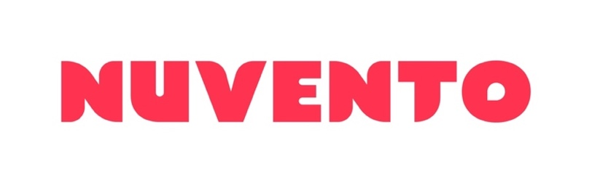

Full Stack Developer & Data Engineer

HITESH BHATT

**DETAILS**

* AWS Practitioner
* Strong knowledge of programming languages like Python and SQL
* Familiarity with big data technologies like Hadoop and Spark
* Understanding of data warehousing and data modeling concepts
* Ability to design, implement, and maintain data pipelines and infrastructure
* Experience with data quality management and troubleshooting data quality issues
* Familiarity with NoSQL databases and distributed systems
* Knowledge of cloud computing platforms like AWS and Azure
* Analytical mindset and attention to detail
* Effective communication and collaboration skills
* Commitment to continuous learning and skill development.

**Full Stack Developer: Vertex Technologies**

During Hitesh’s work in Vertex Technologies, he was responsible for gathering business requirements from both business and customer users. This work was done in conjunction with a small team, where each individual was reliant upon good team work ethics. Hitesh’s manager routinely turned to Hitesh with tasks which required him to bring other team members together for completion. Hitesh worked well in this environment and is both a solid team member and strong relationship builder.  He is a strong communicator, both verbally and technically, and is able to talk to both technology and business stakeholders, explaining his ideas and solutions in a common sense manner.

**CAREER HIGHLIGHTS**

**TECHNICAL CONSULTANT - NUVENTO**

As a Big Data Engineer at Nuvento, Hitesh designs, implements, and maintains big data infrastructure for various Australian Federal Government departments. He works with clients to understand their requirements, develops scalable and efficient data storage solutions, integrates data from various sources, and ensures the accuracy and reliability of data. He has a deep understanding of big data technologies like Hadoop, Kubernetes, Spark, and Kafka, as well as experience with data warehousing and modelling, programming skills in Java, Python or Scala, and experience with SQL and NoSQL databases. Hitesh communicates effectively with clients and team members, explains technical concepts to non-technical stakeholders, and collaborates with other members of the team to deliver high-quality solutions. His role is critical in delivering innovative and effective big data solutions.

**PROFESSIONAL PROFILE**

As a Data Engineer, Hitesh demonstrates a strong understanding of data engineering concepts and technologies. He is responsible for designing, implementing, and maintaining data pipelines and infrastructure for various projects. Hitesh is highly skilled in programming languages like Python and SQL, and is familiar with big data technologies like Hadoop and Spark.

Hitesh has an analytical mindset and an eye for detail, which allows him to identify and troubleshoot data quality issues. He works collaboratively with his team members and communicates effectively with stakeholders to ensure that project goals are achieved on time and to a high standard.

Hitesh is eager to learn and stays up to date with the latest developments in data engineering. He is always looking for ways to improve his skills and is committed to delivering high-quality solutions. With his technical expertise and strong work ethic, Hitesh is a valuable member of any data engineering team.

**Security**: Baseline (NV1 – IN PROGRESS)

**Location**: Canberra

**EXPERTISE**

**FULL STACK DEVELOPER – VERTEX GROUP**

Responsible for developing a solution to translating SQL queries for a Bespoke ATO application to allow users to search sql databases. He also worked as a Data Engineer performing ETL pipelines.

**Responsibilities**

* Developing access for technologies to take advantage of the Enterprise Data Hub (Cloudera-Hadoop Platform) using a variety of technologies such as Spark-Scala & Java, Impala, HDFS, Yarn.
* Supporting Teradata Appliances and the associated tools and utilities (TTU).
* Loading data into the Data Lake (EDH) and developing a pipeline using primarily spark and kafka.

**Responsibilities**

* Responsible for networking, design, installation and maintenance services.
* Maintain the company’s network infrastructure.
* Networking and providing support for Windows, Macintosh and Linux issues.
* TCP/IP networking and hardware maintenance and repair.

**SOFTWARE AND IT SUPPOT ENGINEER – AINSLIE GROUP**

Hitesh’s role was responsible for networking, designing, installation and maintenance of IT services across the Ainsle Group. This role required Hitesh to support users and network administrators whilst maintaining and improving the company’s network infrastructure.

**PREVIOUS PROFESSIONAL ROLES – Past 5 Years**

**Responsibilities**

* Works with clients to understand requirements
* Develops scalable and efficient data storage solutions
* Integrates data from various sources and ensures accuracy and reliability
* Has a deep understanding of big data technologies
* Communicates effectively with clients and team members
* Collaborates with team members to deliver high-quality solutions

**Achievements**

* Successfully designed and implemented big data infrastructure for several Australian Federal Government departments
* Improved data accuracy and reliability by developing scalable and efficient data storage solutions
* Identified and resolved performance issues in big data infrastructure, resulting in increased system availability and improved overall performance
* Received positive feedback from clients on effective communication and collaborative approach.

**Technology**

* Hadoop, Spark, Kafka, Kubernetes, SQL databases, NoSQL databases, Java programming language, Python programming, Scala programming, AWS (Cloud), Azure (Cloud)

**TECHNICAL CONSULTANT - NUVENTO**

As a Big Data Engineer at Nuvento, Hitesh designs, implements, and maintains big data infrastructure for various Australian Federal Government departments. He works with clients to understand their requirements, develops scalable and efficient data storage solutions, integrates data from various sources, and ensures the accuracy and reliability of data. He has a deep understanding of big data technologies like Hadoop, Spark, and Kafka, as well as experience with data warehousing and modeling, programming skills in Java, Python or Scala, and experience with SQL and NoSQL databases. Hitesh communicates effectively with clients and team members, explains technical concepts to non-technical stakeholders, and collaborates with other members of the team to deliver high-quality solutions. His role is critical in delivering innovative and effective big data solutions.